Project Description and Scratch Game Outline

Project Description: Your Own Math Adventure Game
In this project, you create a math quiz game with a story! Each time you answer a question correctly, you move forward in your adventure for example, traveling through a forest, meeting new characters, or exploring a castle.
But remember: your story can be anything you like! You don’t have to follow my example. You can use different backgrounds, characters, or themes maybe a space journey, a treasure hunt, or an underwater quest. You also decide where to place the math questions and answers on the screen. The important part is that players answer math questions to progress through your story.

Materials Needed
- Scratch account or desktop app
- Sprites for:
Characters or objects you meet on your journey
- Background images (forest, castle, space, etc.) for each scene or level
- Variables:
num1, num2 (for your math questions)
correctAnswer (to check answers)
- Blocks from these categories:
Event are used to start the game, trigger code when something happens
Sensing (ask, answer) for input
Variables to store numbers and progress
Control (if, else, repeat) to check answers and control story flow
Looks (say, switch backdrop) to show story and feedback
Logic Behind the Game
- Generate a math question: Randomly pick two numbers (num1 and num2) and calculate the correct answer (correctAnswer).
- Ask the player: Use the ask block to show the math question, e.g., “What is 7 + 5?” The player types their answer.
- Check the answer: Compare the player’s input (answer) with correctAnswer.
- Progress the story:
  - If the answer is correct, increase your progress variable to move the story forward.
  - Change the background and sprites to show the new part of the adventure (new scene, character, or event).
  - If the answer is wrong, give feedback like “Try again!” and ask the same question again.
- Repeat: Keep generating questions and moving through the story until the player reaches the end.
How It Helps Students:
- Reinforces mental addition skills.
- Encourages creativity in building a story and designing scenes.
- Introduces basic coding logic (if/else, variables, random numbers).
- Builds confidence using Scratch independently without complex custom blocks.

Scratch Game Outline: Coordinate Grid Chase
Project Description:
In this Scratch project, students create a cat-and-mouse chase game that reinforces their understanding of coordinates on a grid. The player controls a cat sprite that chases a mouse sprite. Each time the cat touches the mouse, the score increases, and the mouse teleports to a random coordinate on the grid.
This game helps students:
- Practice identifying and predicting coordinate positions (x, y)
- Understand grid movement and spatial awareness
- Use Scratch coding blocks to build an interactive game

Materials Needed:
- A Scratch account or Scratch desktop app
- Grid-style background (optional but recommended for visual clarity)
- Sprites:
  - Cat (player-controlled)
  - Mouse (moves to new coordinates when touched)
- A variable named:
  - score (to track how many times the cat catches the mouse)
  - x coordinate (to generate the random coordinate)
  - y coordinate (to generate the random coordinate)

Scratch Blocks Used:
- Motion: go to x: y:, move steps, point towards
- Events: when green flag clicked
- Control: forever, if then
- Sensing: touching [sprite]
- Operators: pick random
- Variables: score, x position, y position

Cat Sprite (player)
- Starts at the center of the screen
- Points towards the mouse pointer and moves in that direction
- Continuously checks if it is touching the mouse
- If yes, increase the score by 1
Cat Script:
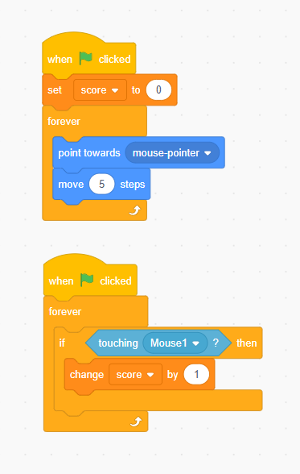
🐭 Mouse Sprite (target)
- Starts at a random coordinate on the stage
- When touched by the cat, moves to a new random coordinate on the grid
Mouse Script:
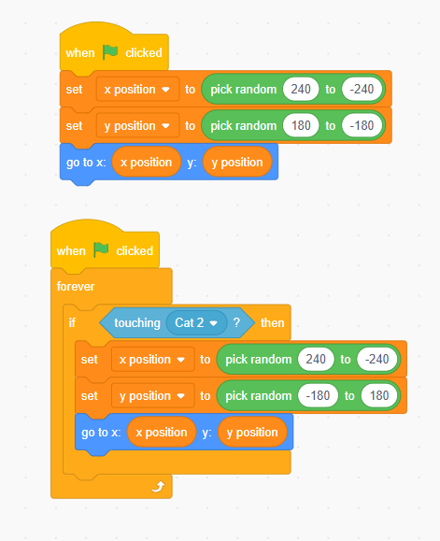
Learning Objectives:
- Understand how x and y coordinates determine position on a grid
- Read and predict positions using (x, y)
- Apply logical thinking to control movement and scoring
- Improve familiarity with basic Scratch blocks and loops

Extensions and Differentiation:
- Display Coordinates: Show the current x and y position of the mouse when it moves.
- Custom Design: Students can redesign the sprites or make their own mazes or grid themes (jungle, underwater, space, etc.).
- Add Timer: Use a timer to make it a race to get as many points as possible in 30 seconds.
Assessment Ideas:
- Can the student explain how the x and y positions control where the mouse appears?
- Can they adjust the grid range or movement speed to match their design goals?
- Can they describe the purpose of each block or script?
- Can they identify which coordinates the mouse is at based on its position on the stage?

